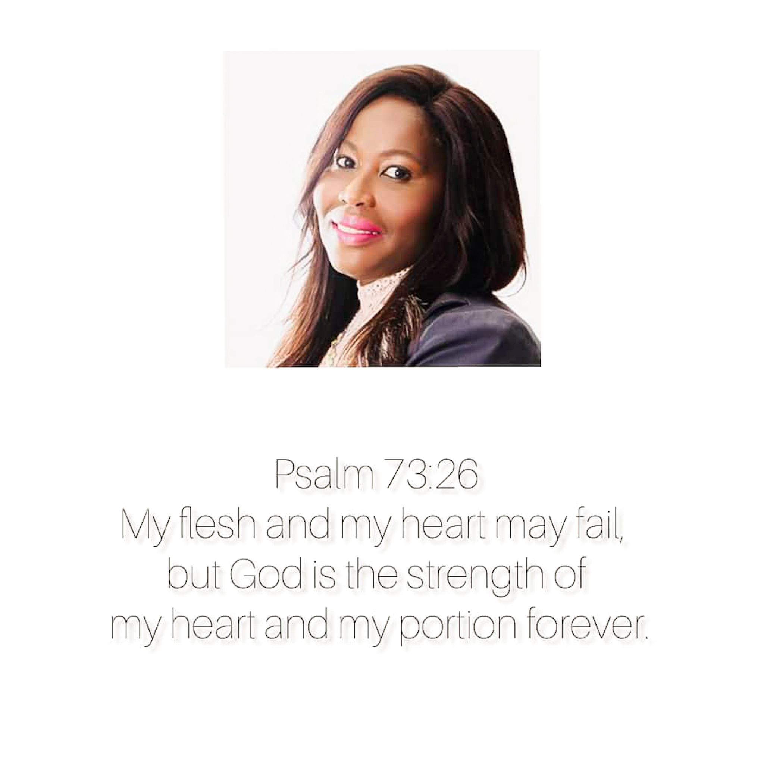  song's booklet  @ozora.art.blog | Abstract  Songs from a hymn book are included in this booklet, which are commonly used in Lutheran churches. It was created to assist those who use music to communicate with God. Read on and let your heart shout praises to God, no matter what situation you're in.  Ozora Thato Seopa  https://ozora.art.blog

Table of CONTEnt
  - Lauretta Maphaka Teffo
Born: 09 August 1972 – Buried: 04 September 2021

Psalm 96 : 1
Sing to the Lord, all the world.
Page numbers
- 197: Legae la ka ga leo mo faseng
- 225: Ditshegofatso tsa Raweso
- 196: Khutso e teng
- 290: Jesu Mopholosi wa ka
- 292: ke hloka wena mong
- 287: O ntshware ka seatla
- 337: Ka Kriste ke a phela
- 304: Sala botse sala Moreneng
John 11:25-26
Jesus said to her, “I am the resurrection and the life. The one who believes in me will live, even though they die; and whoever lives by believing in me will never die. Do you believe this?”

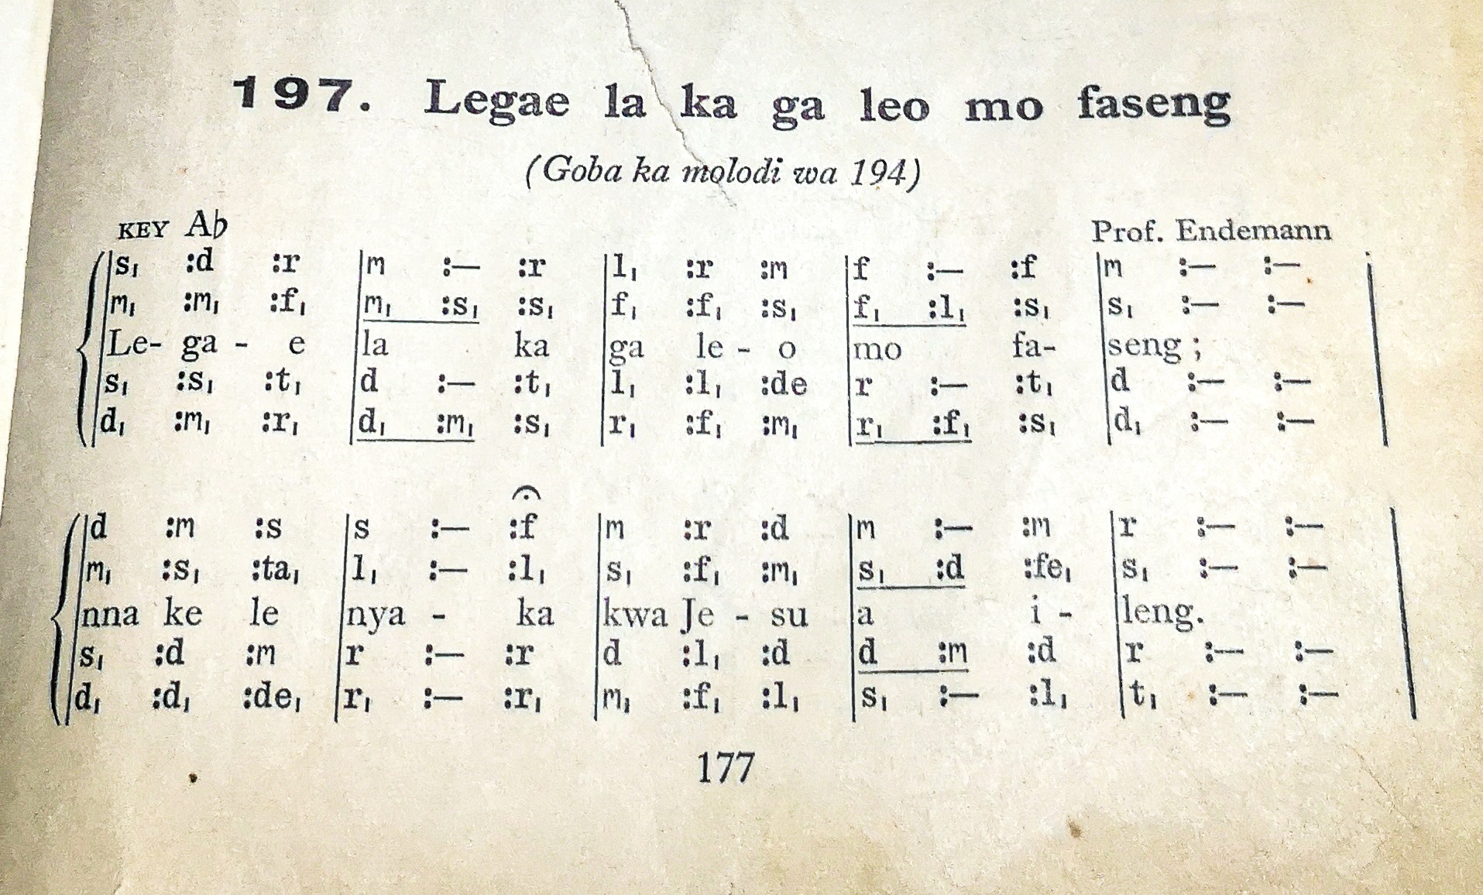
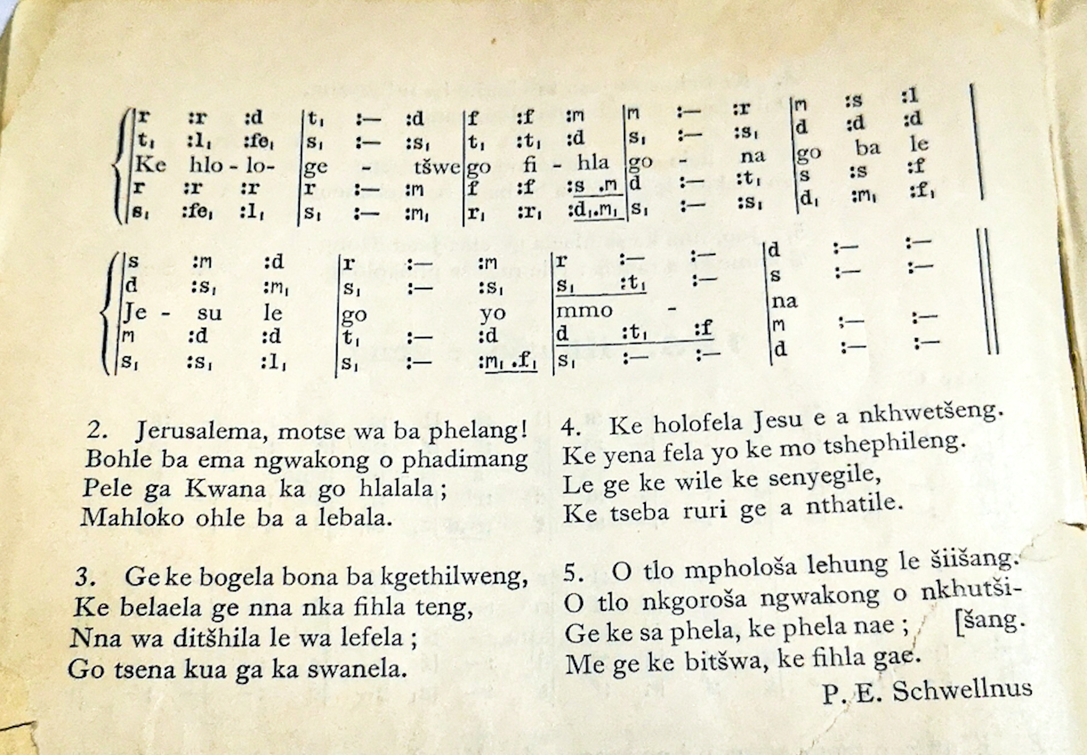
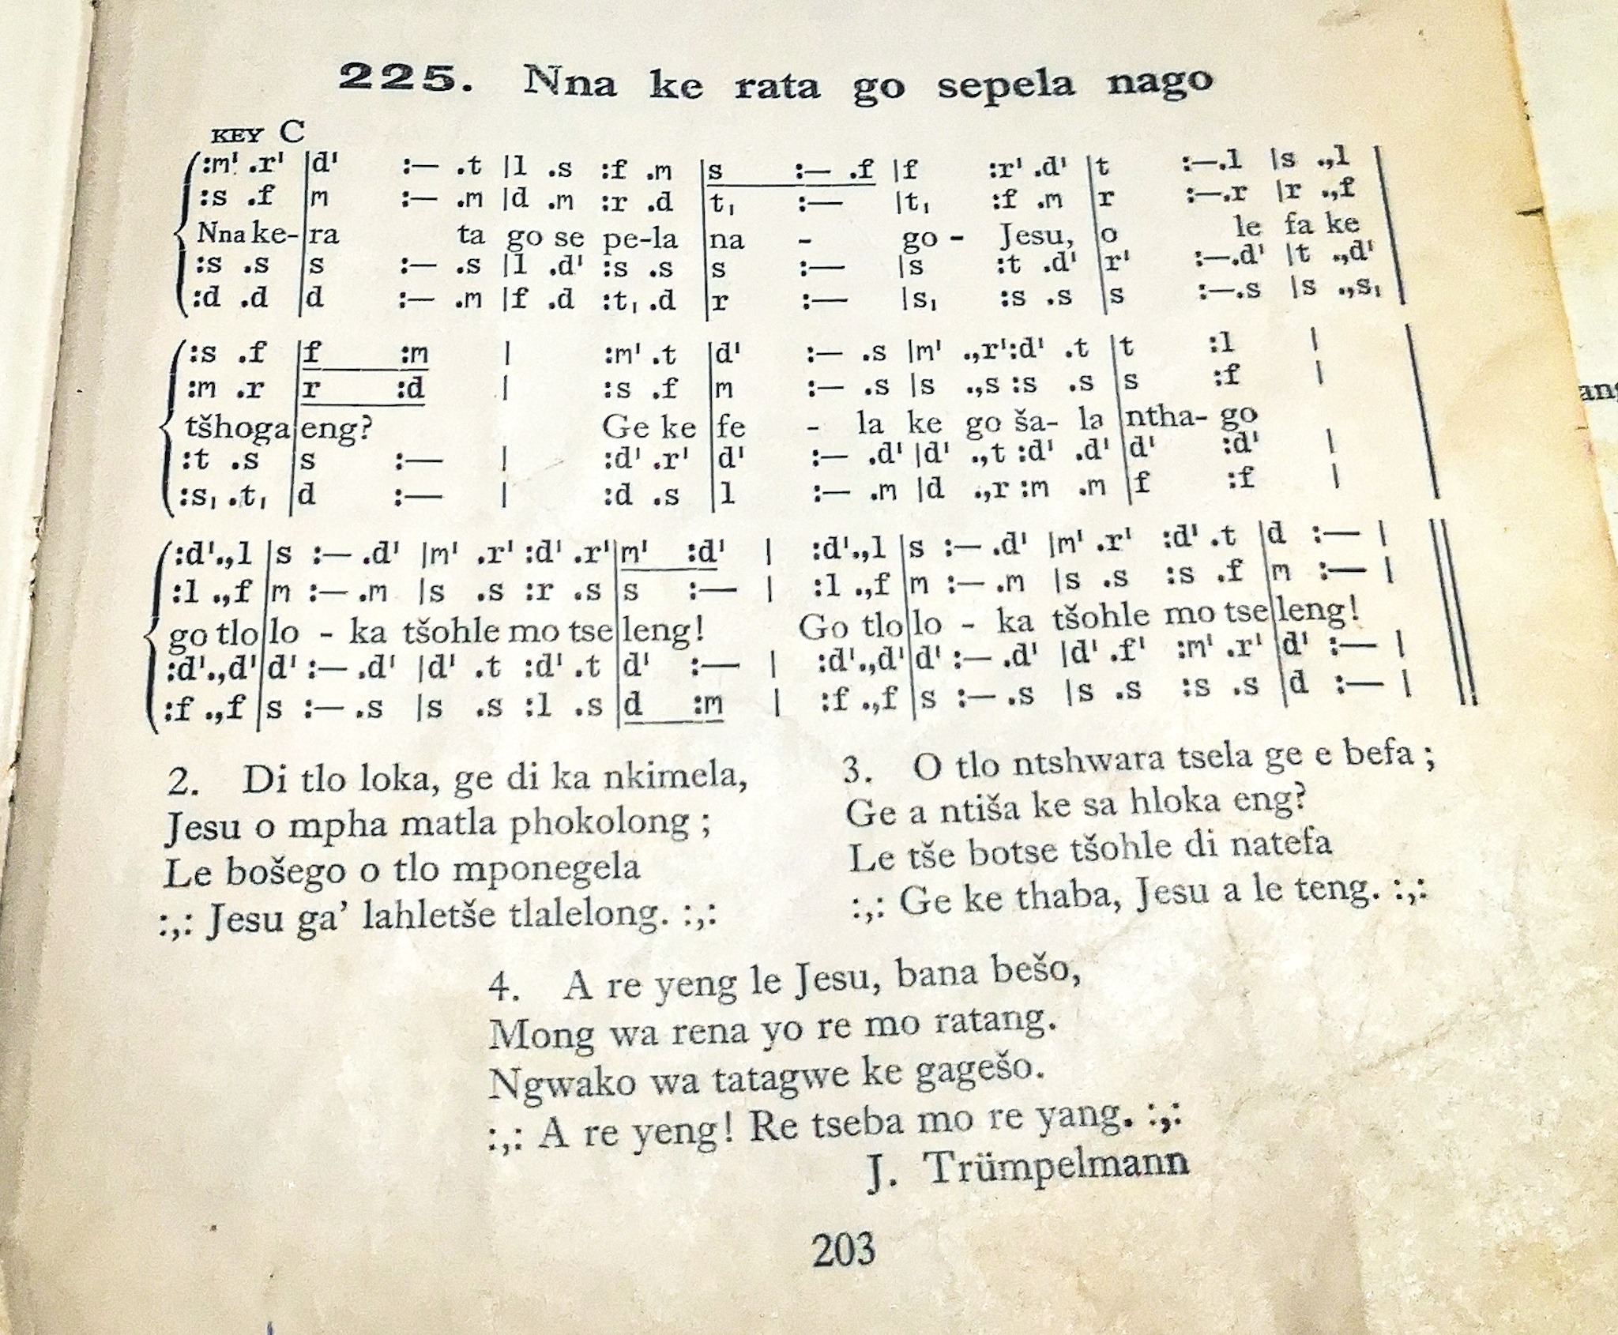

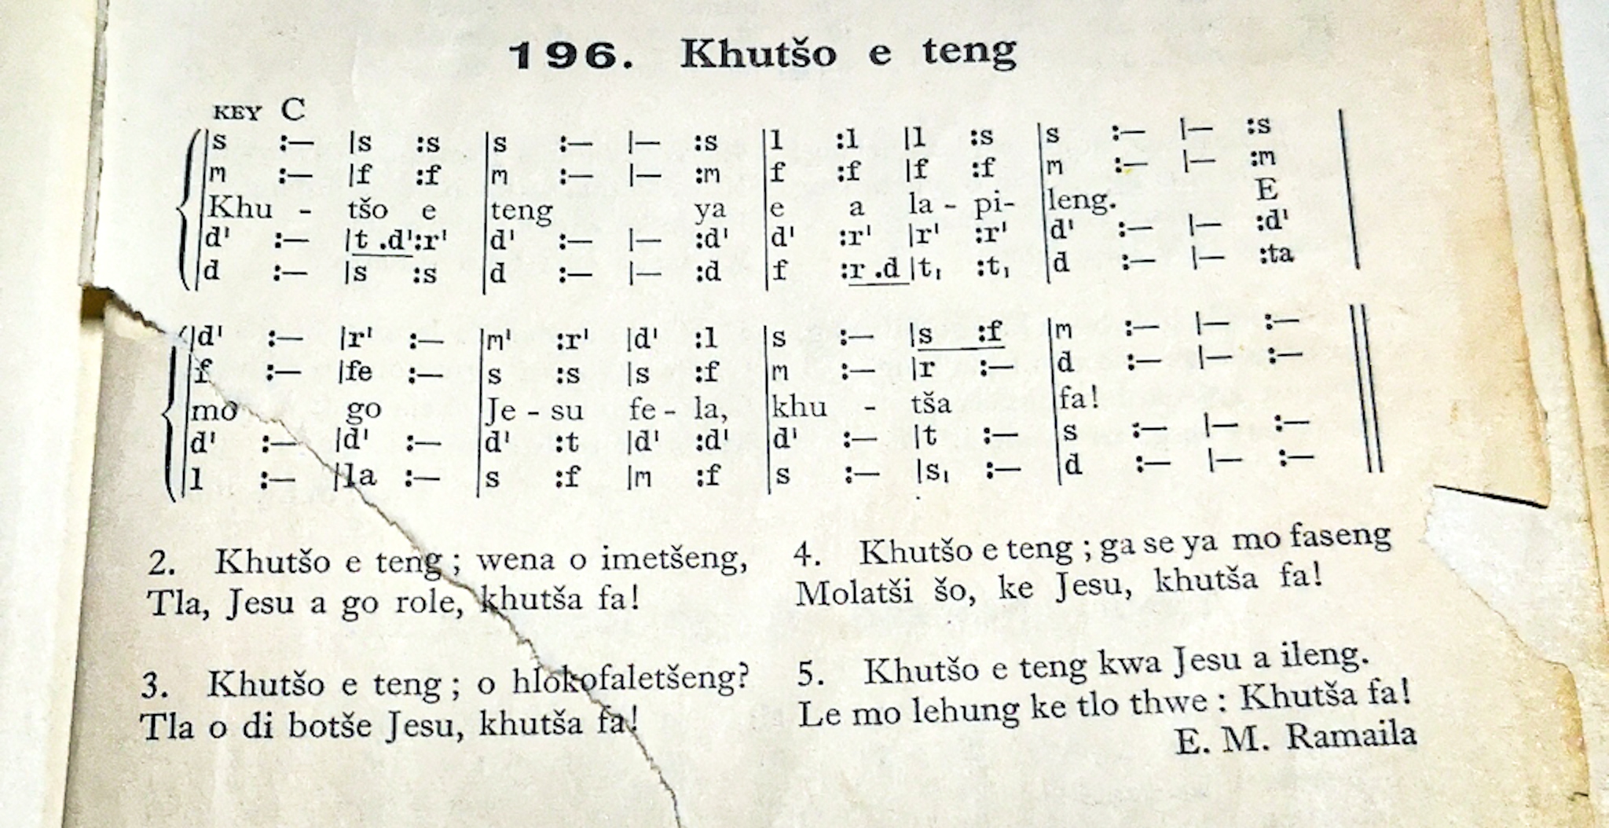

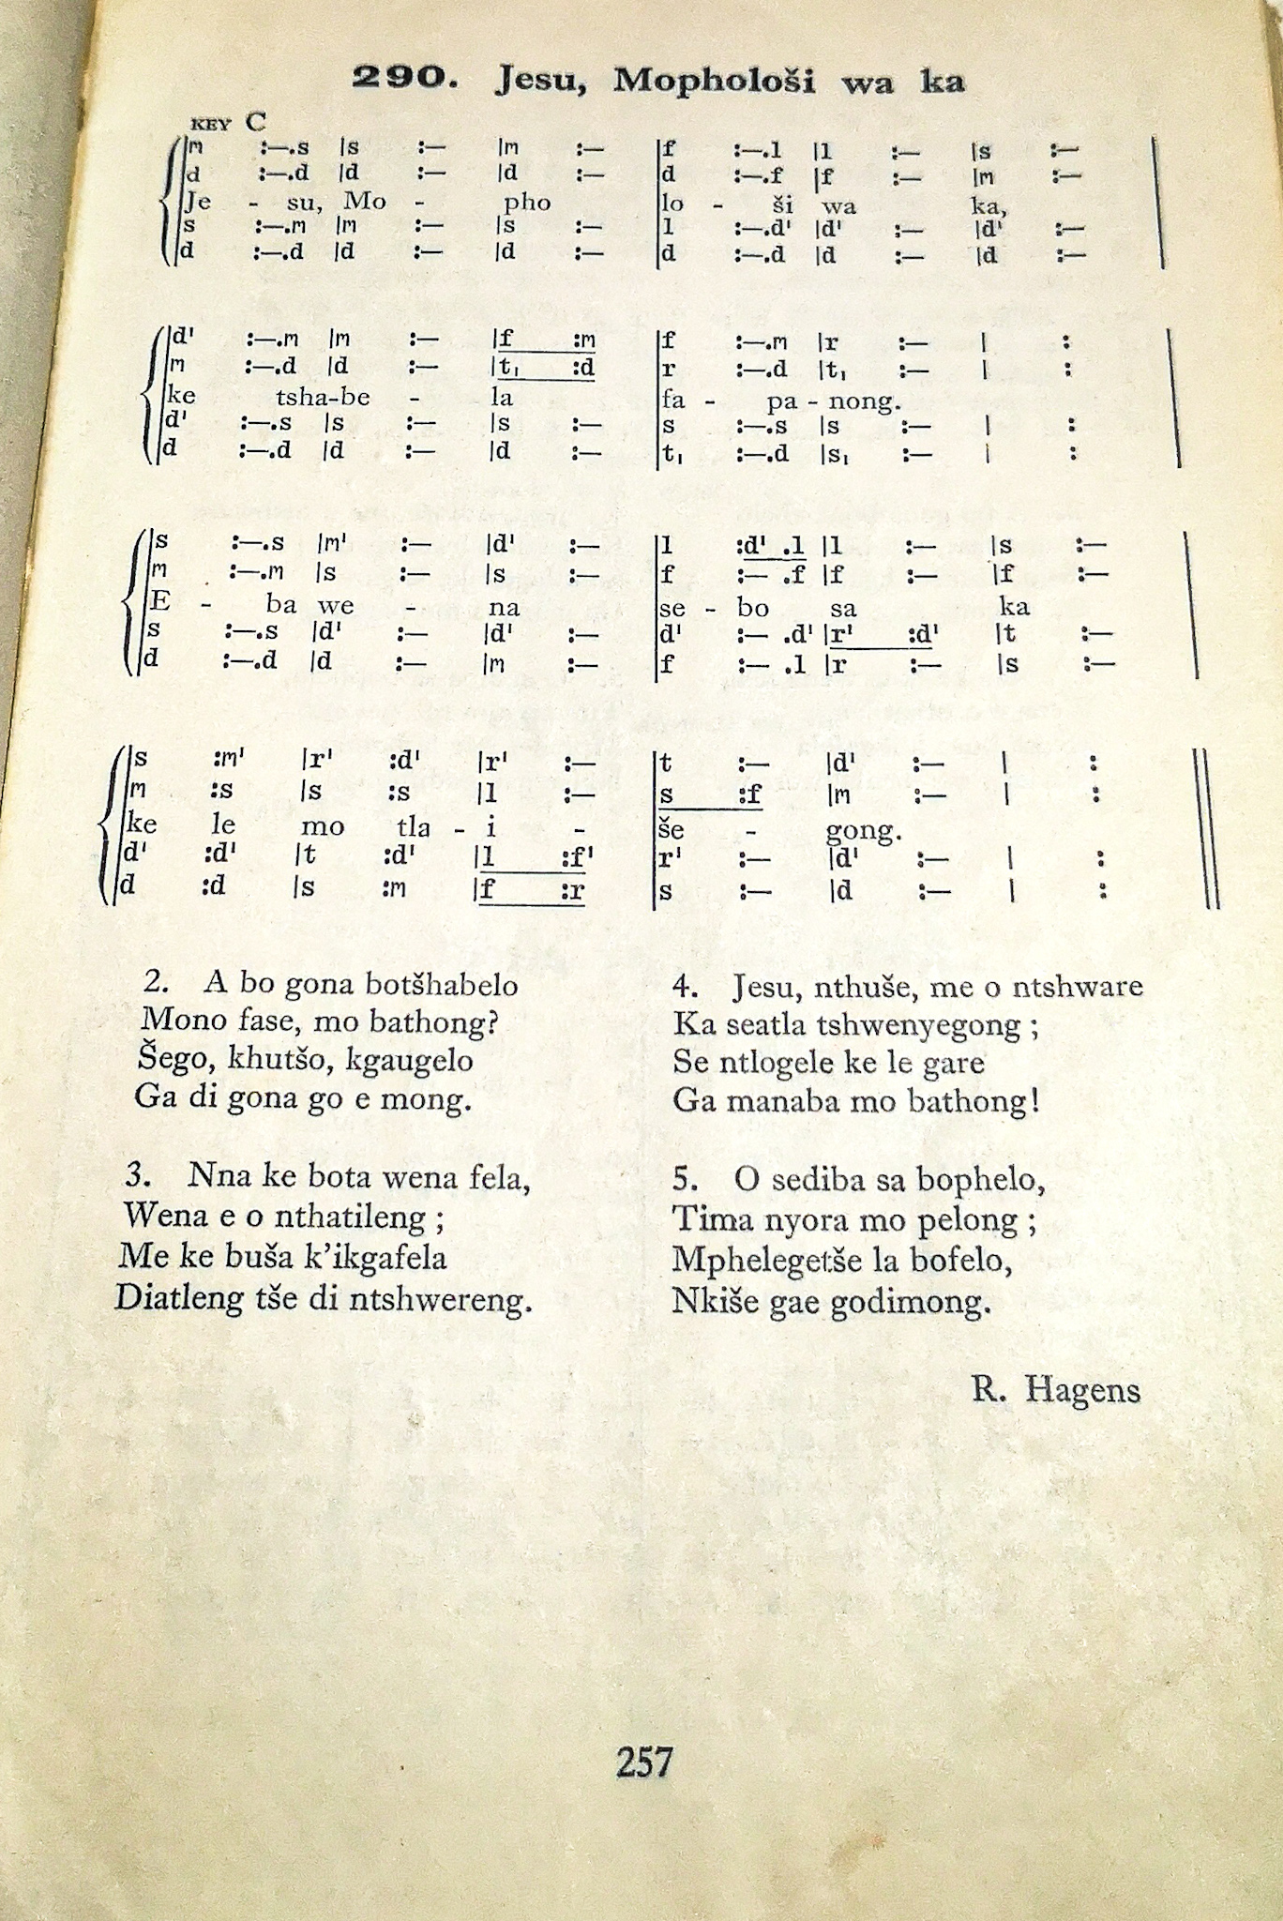
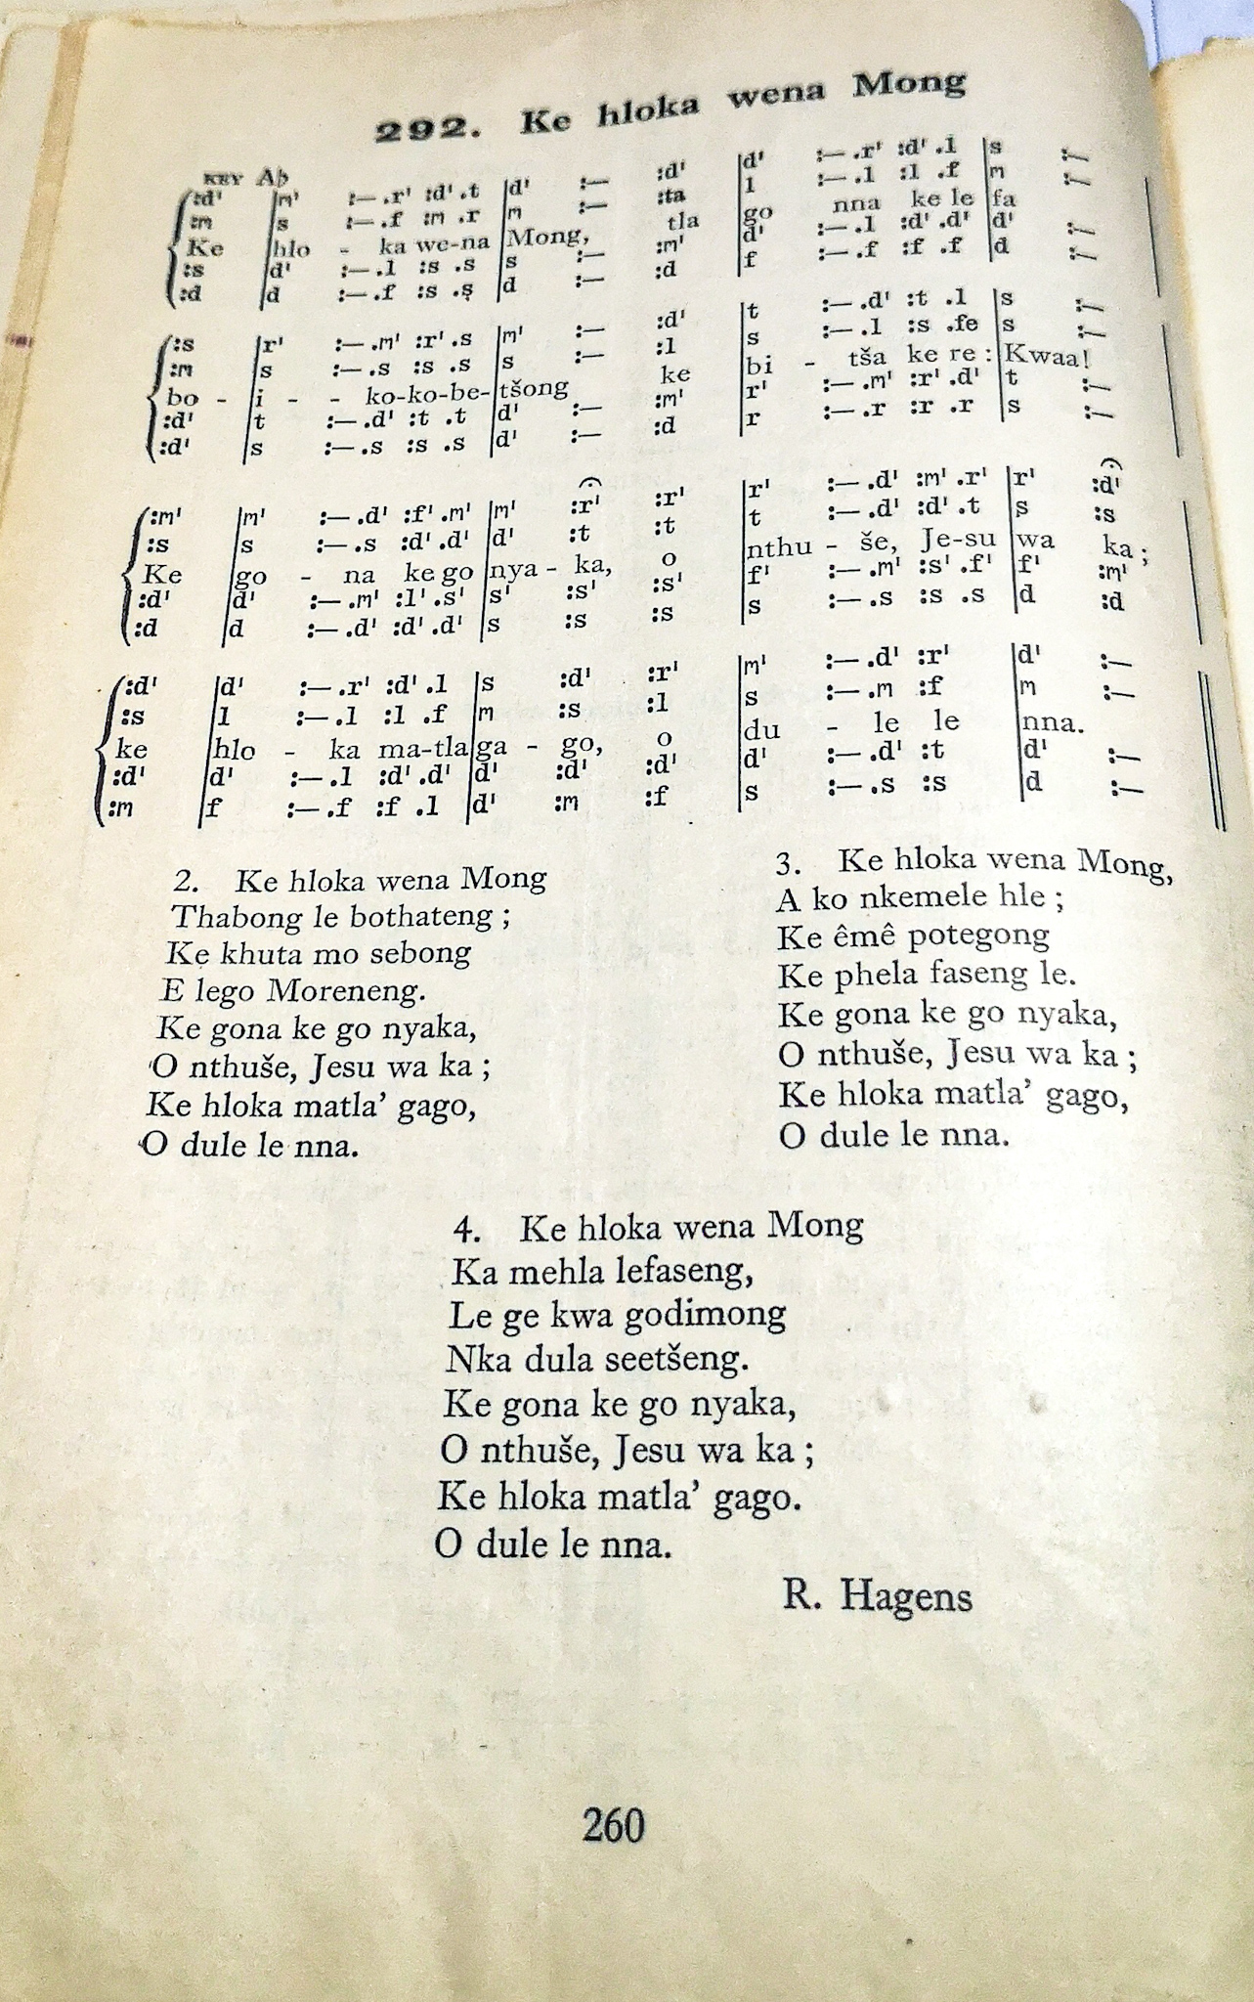
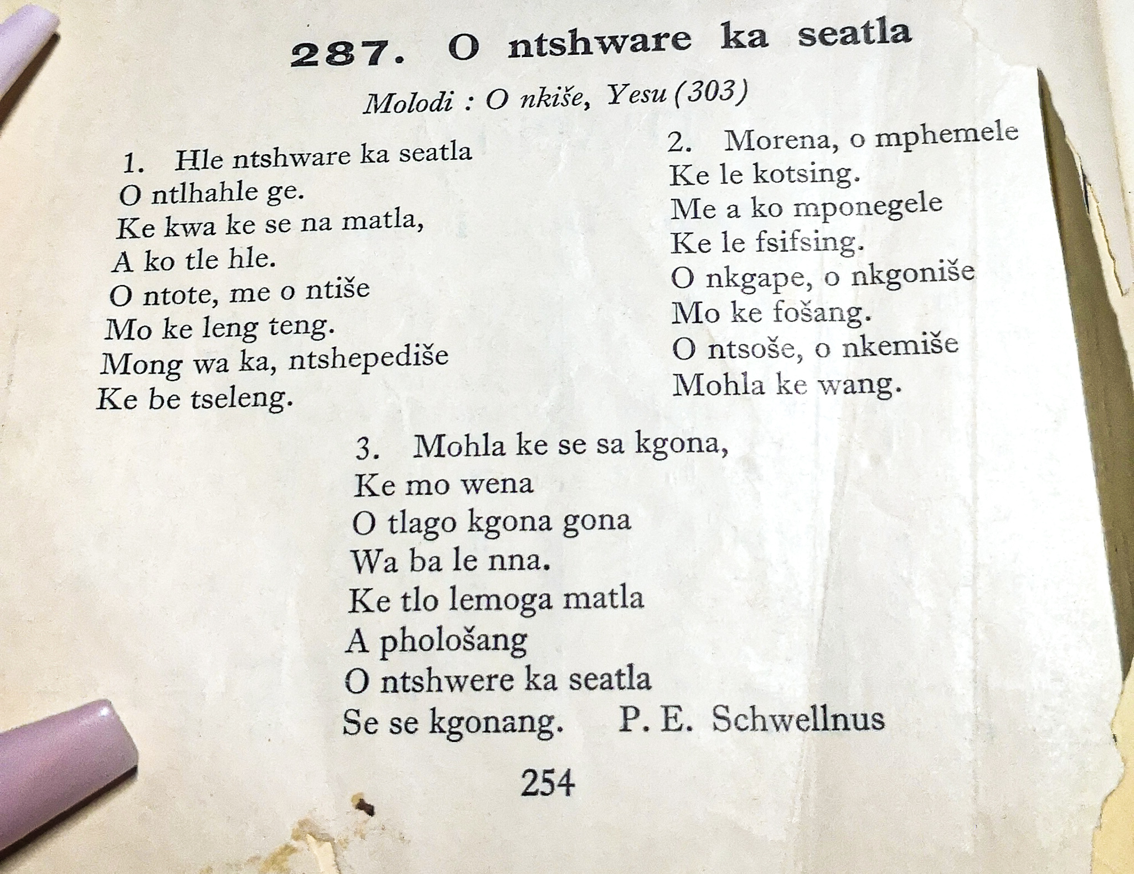

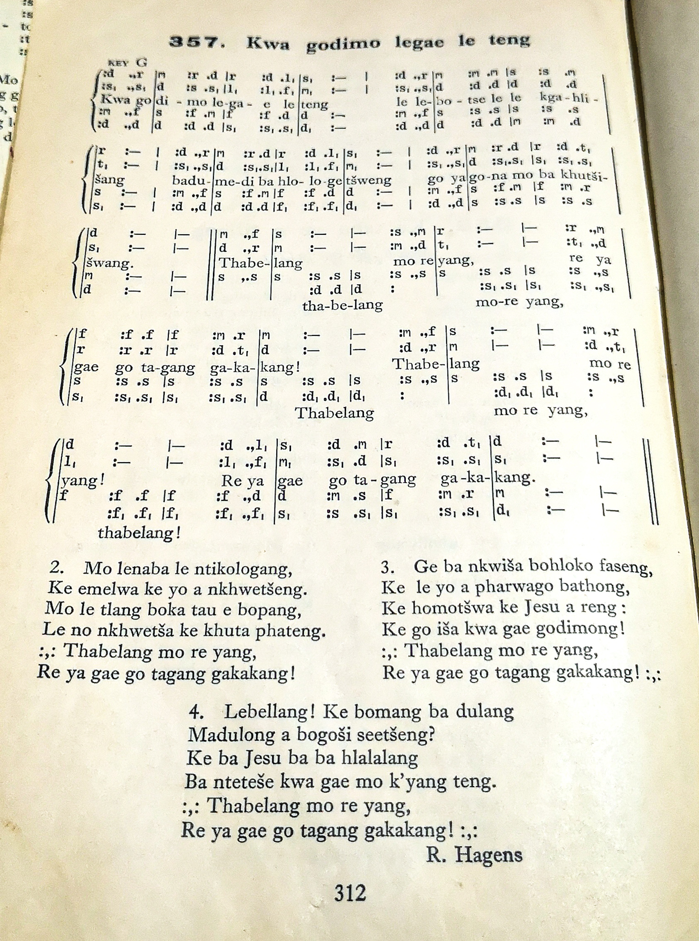

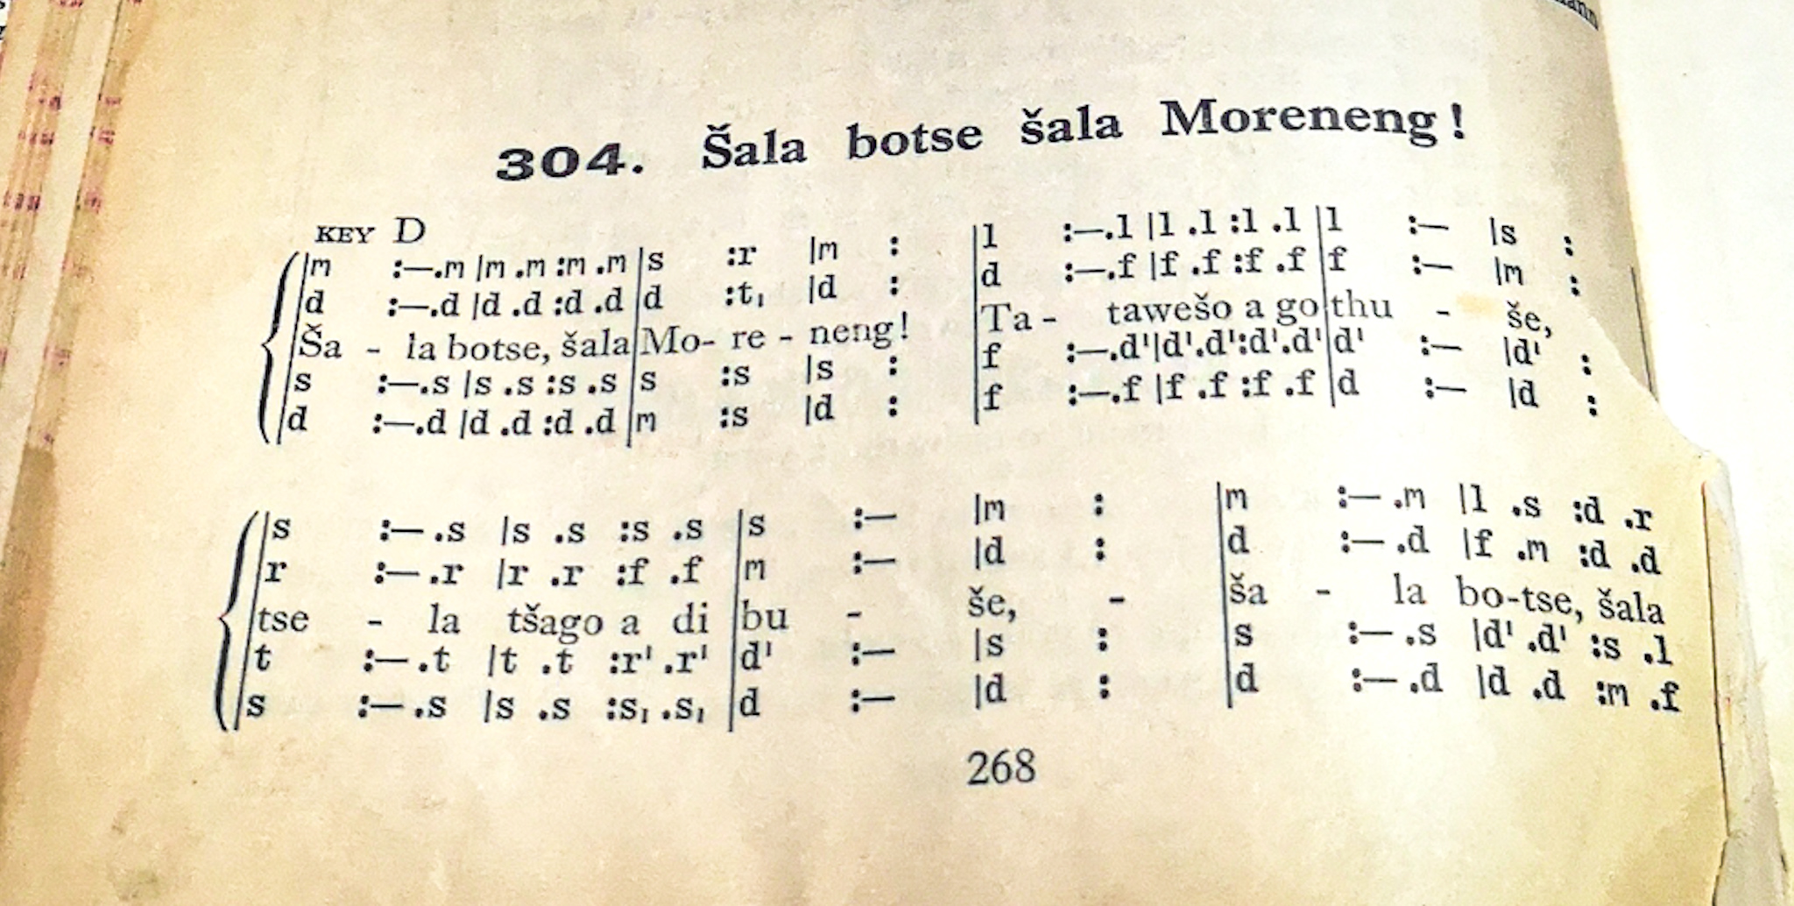
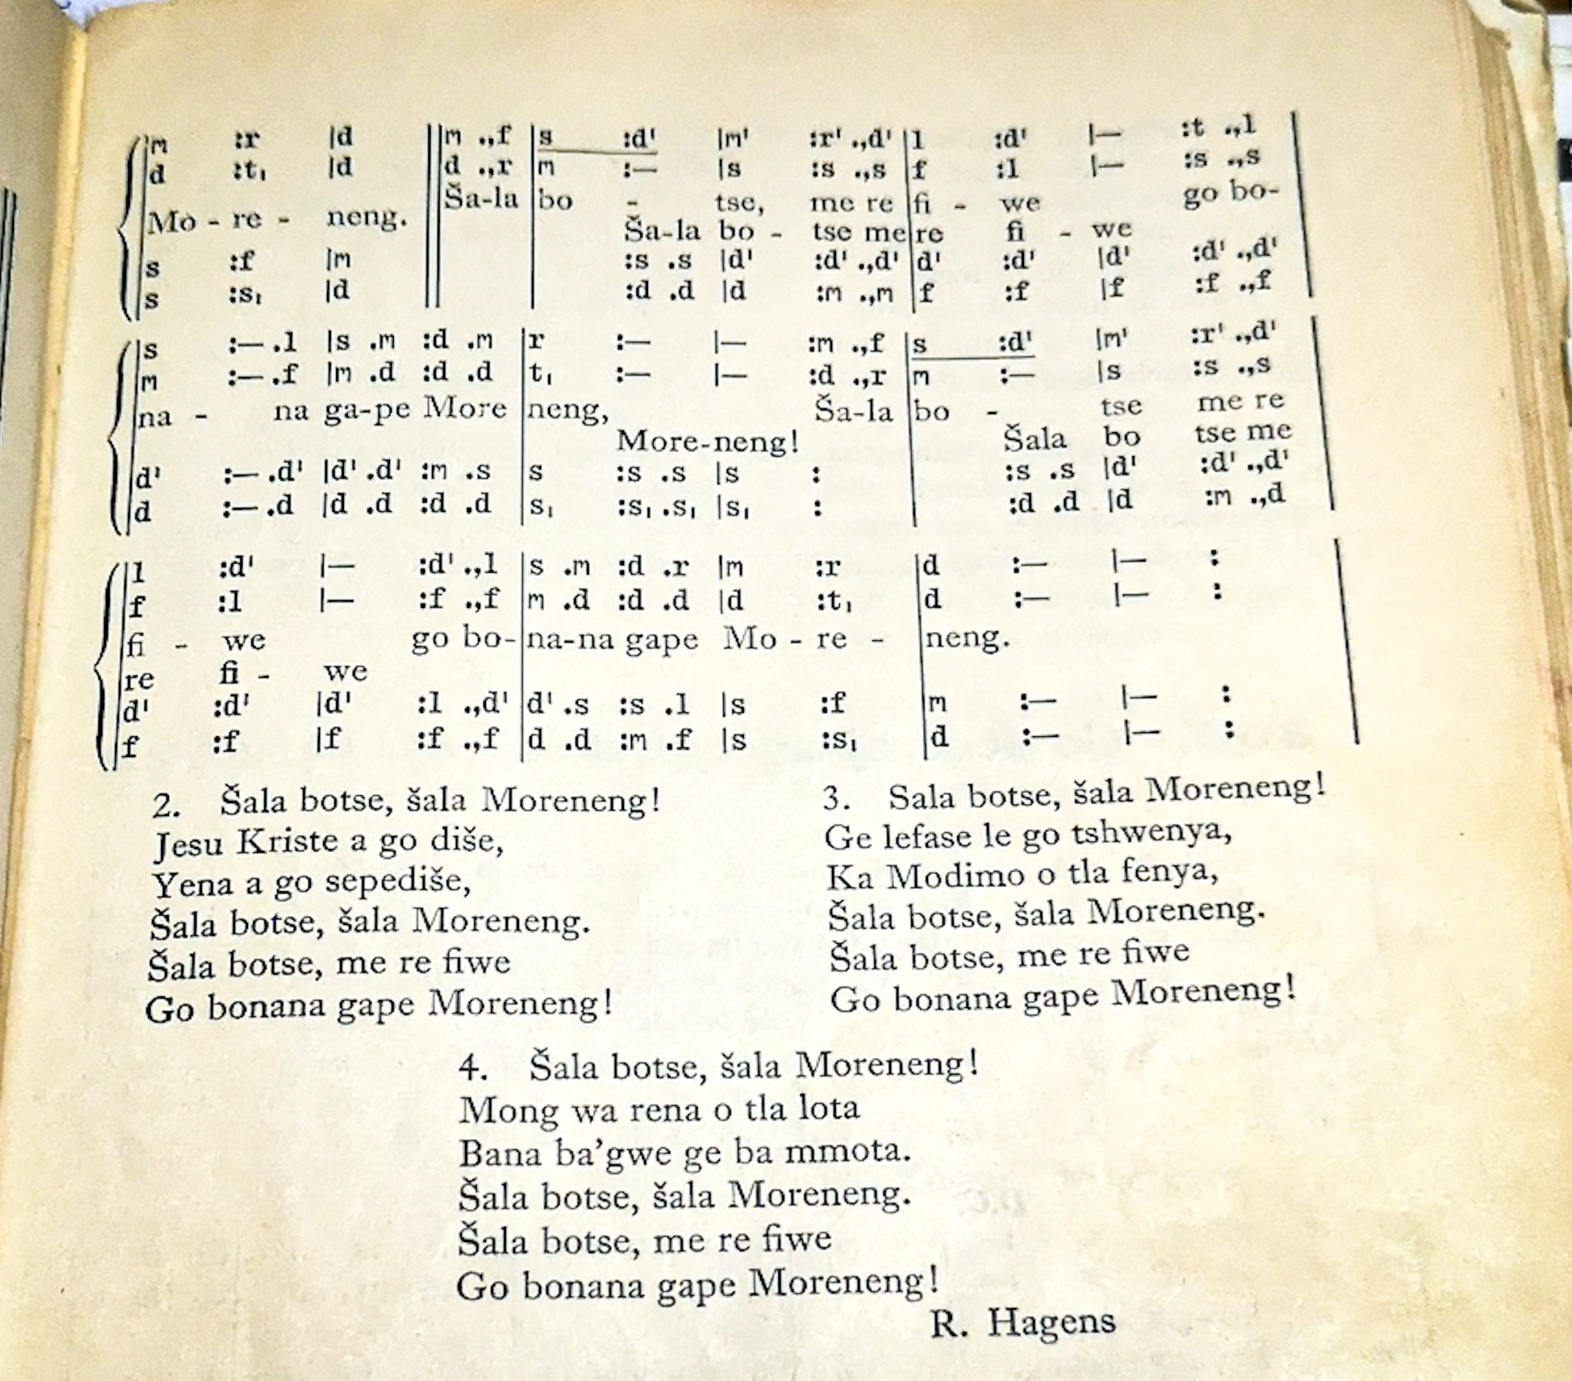

2 Corinthians 5:8

We are confident, I say, and would prefer to be away from the body and at home with the Lord.

Creator : T. Seopa
-Miss Teffo you were sent from heaven, and now the Lord has summoned you. We are going to miss you, RIP, lovely.

